**[preview]**

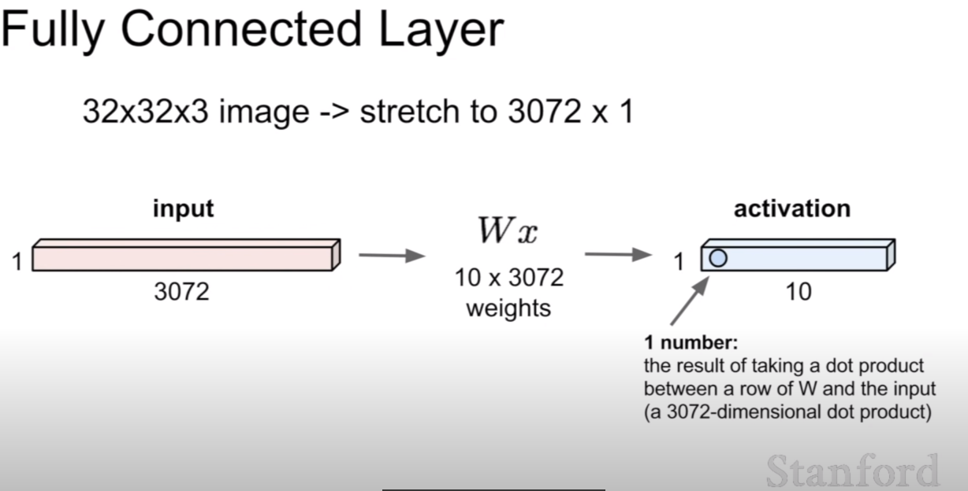

**[Differences with Fully Connected Layer]**

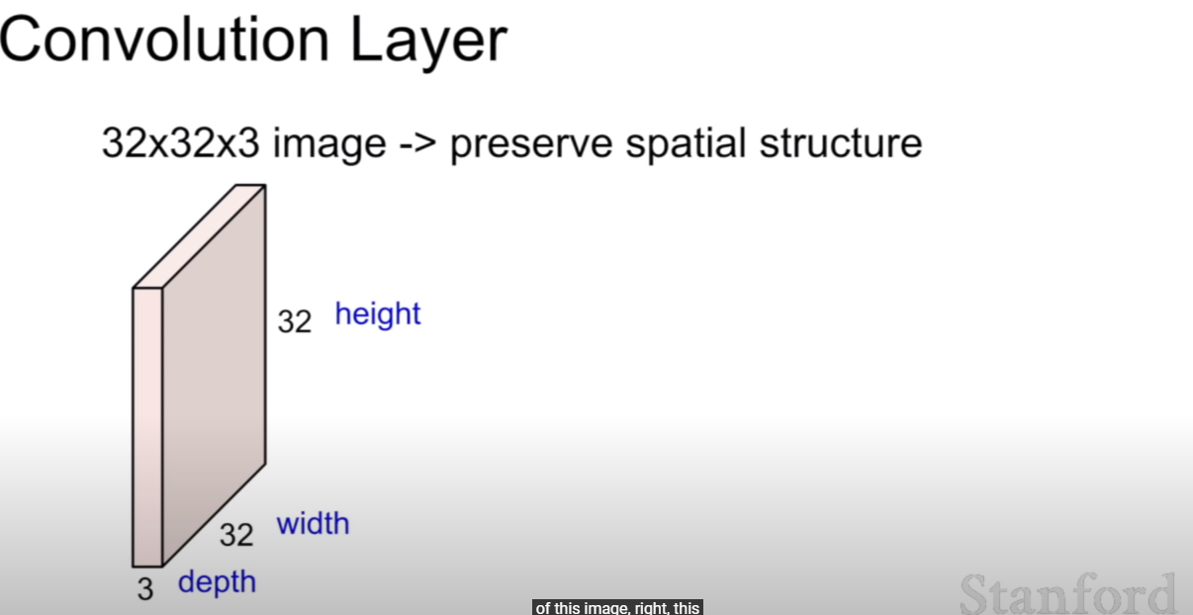

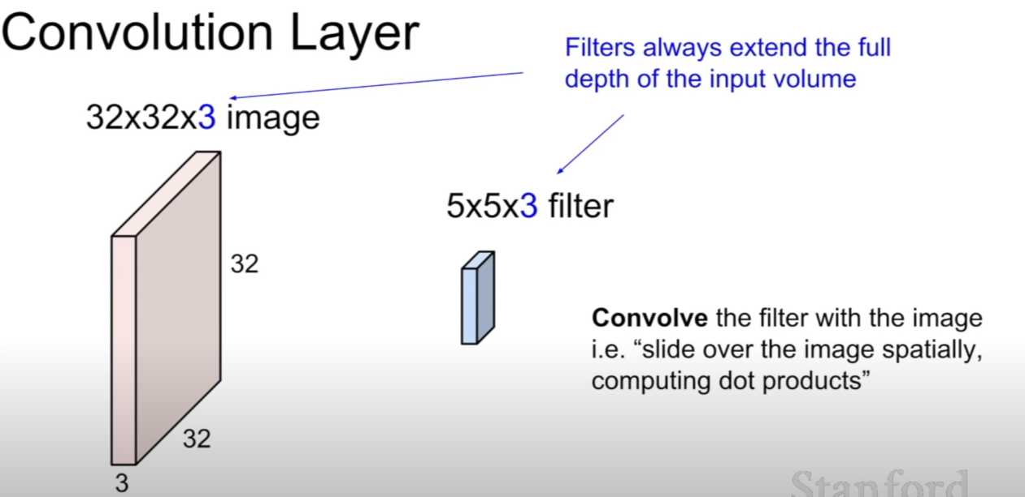

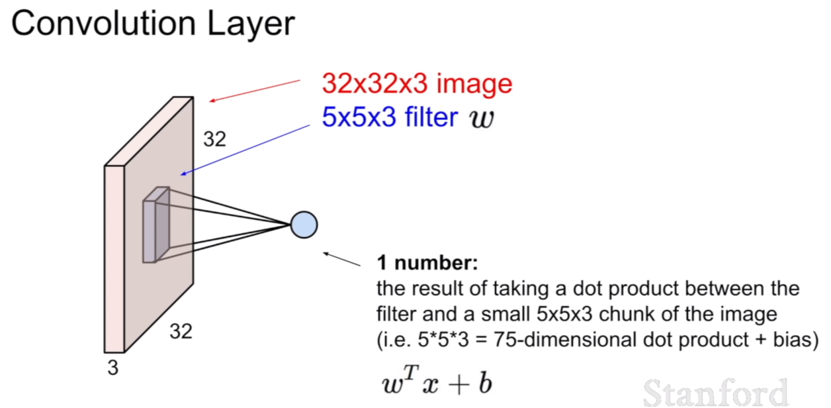

- basically, we have to stretch W to 1-D vector to calculate dot-product.

- but just laid the W onto the input array and multiply element-wisely will return same result.

- each dot-product make one value.

- FInally the below array will be created.

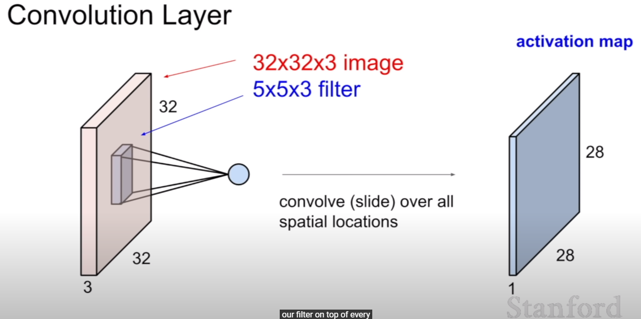

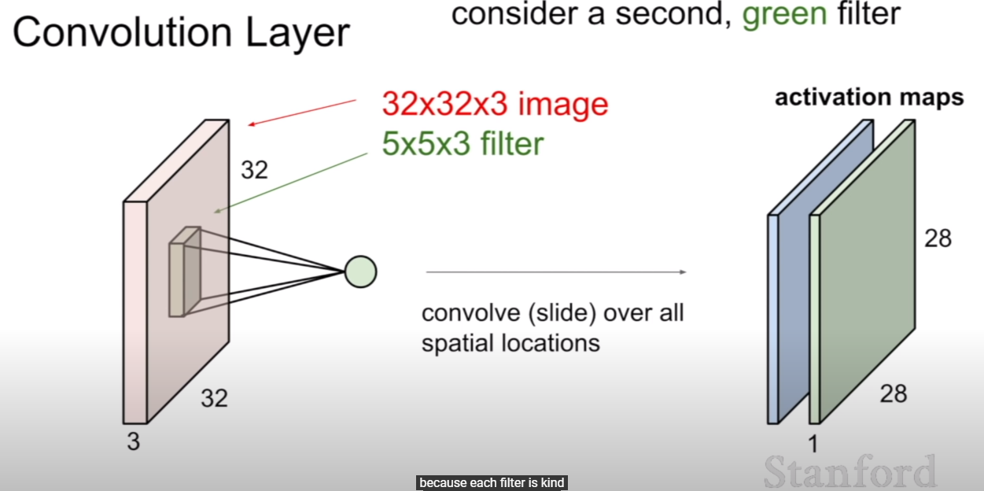

- we can use multiple filter like green one.

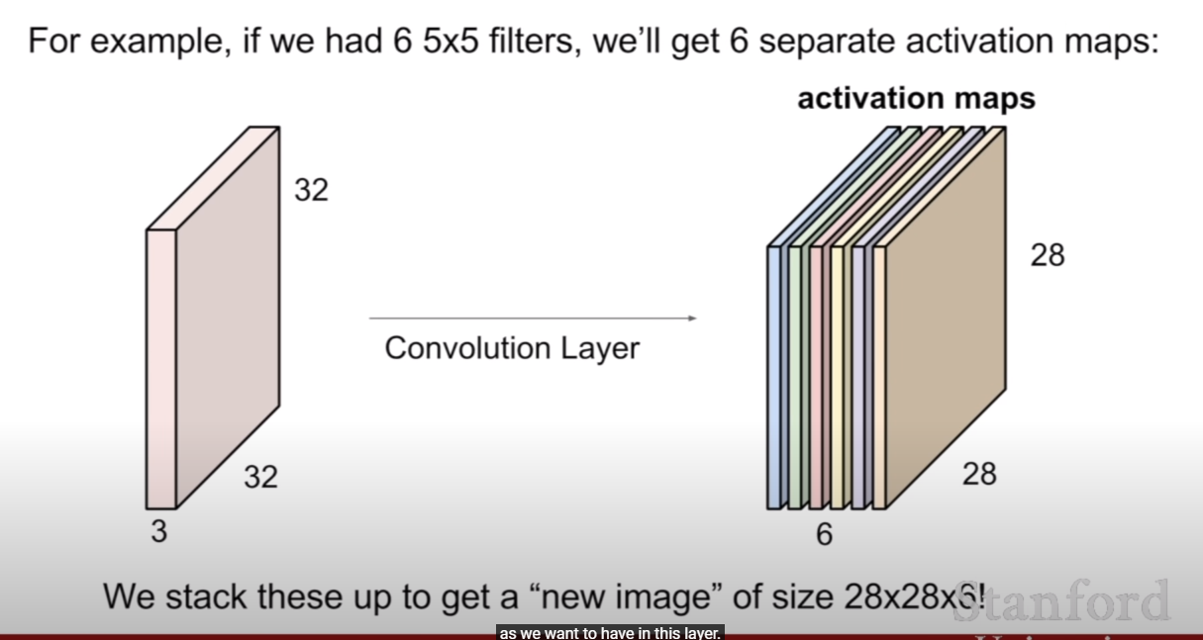

- as we can see, we can do as we want.

- so in here, the filter size is 6 x 5 x 5 x 3.

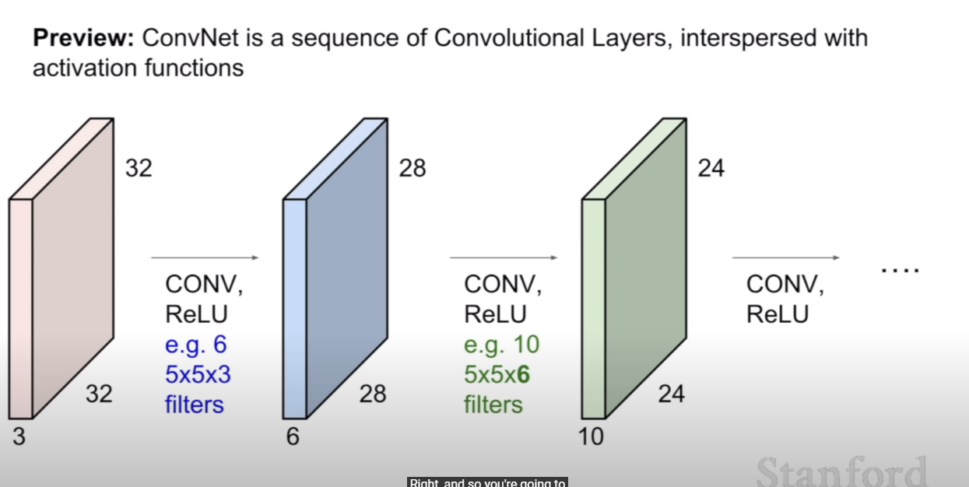

- after that, we use activation fuction.

- and filter size is a design choice. but some size are chosen heuristically.

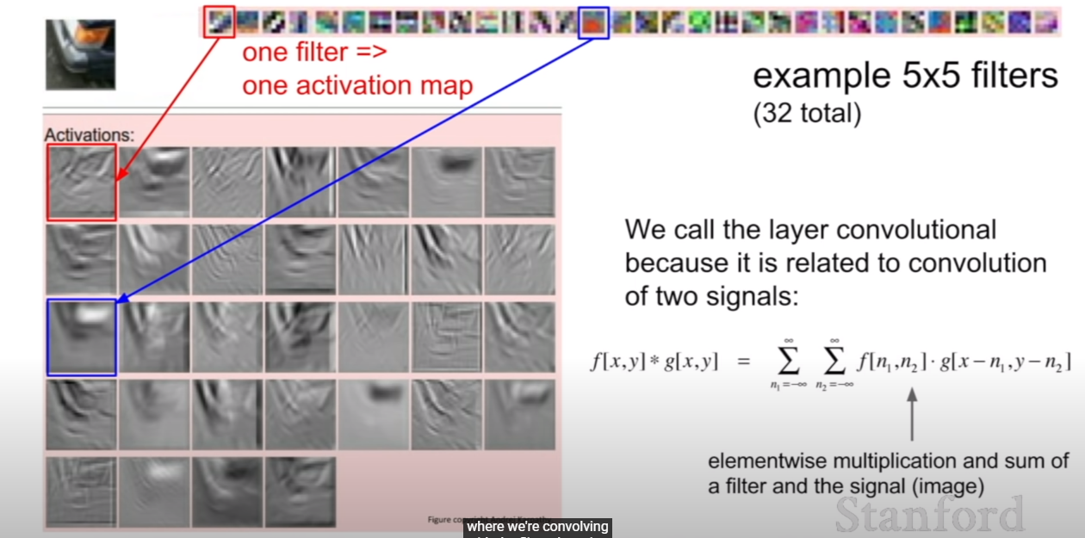

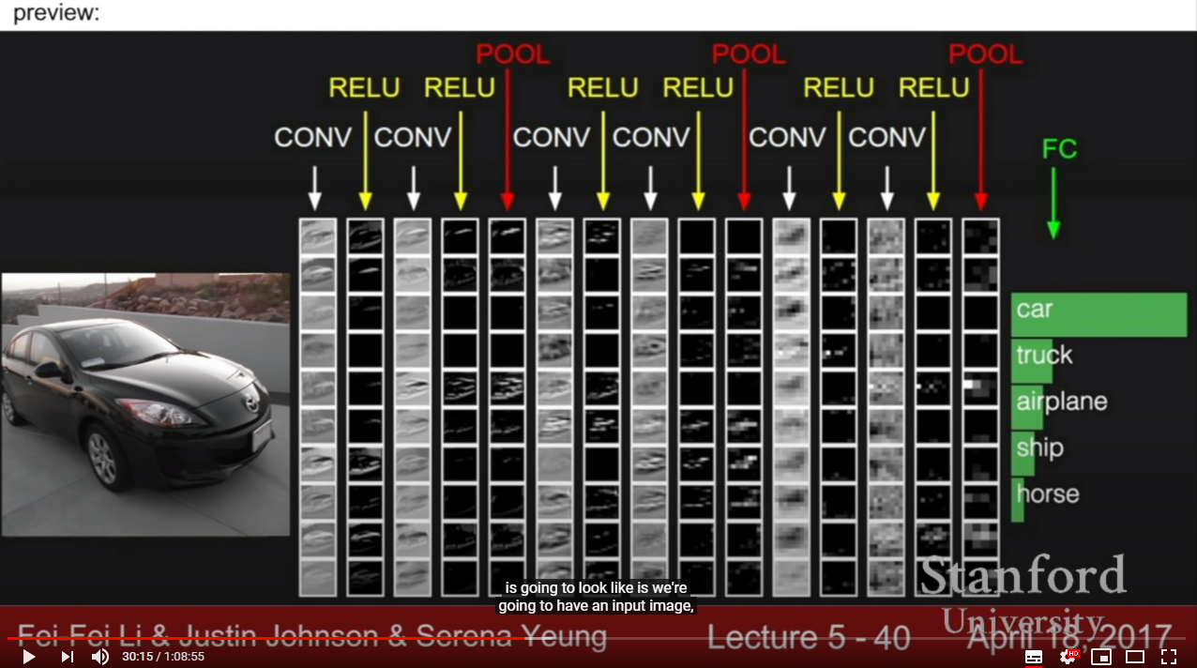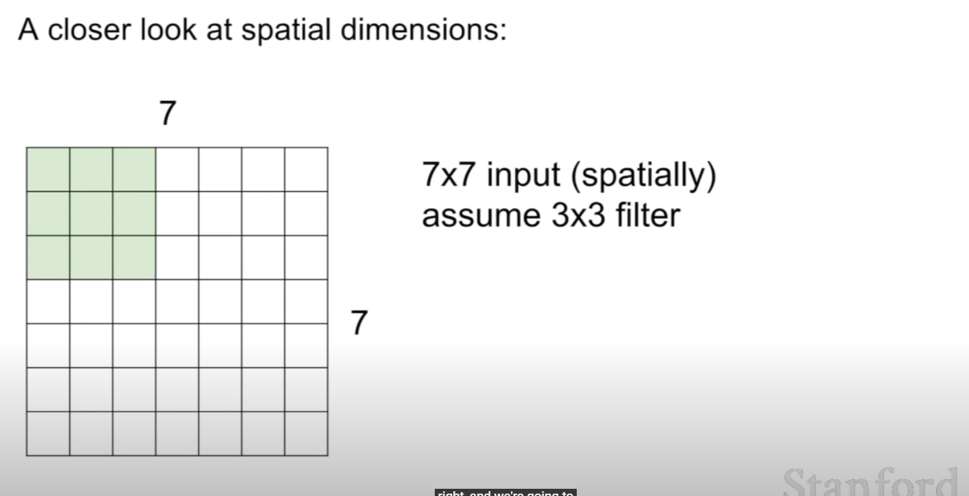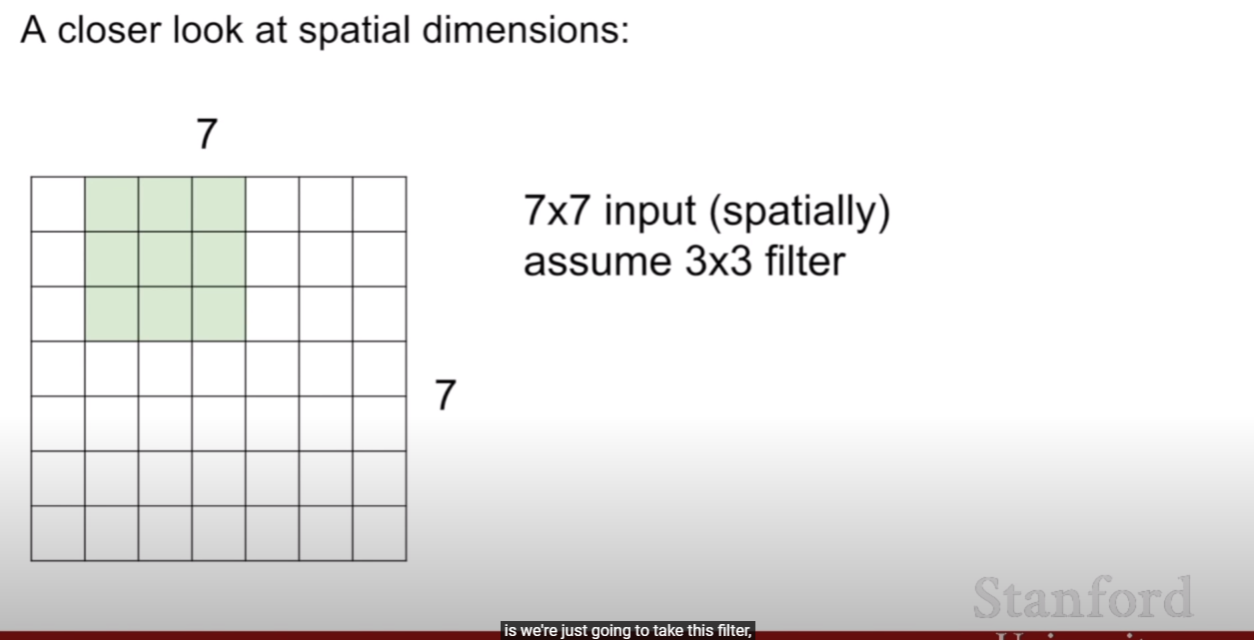

- this is the way to apply filter into input volume, just slide the filter with multiply element-wisely.

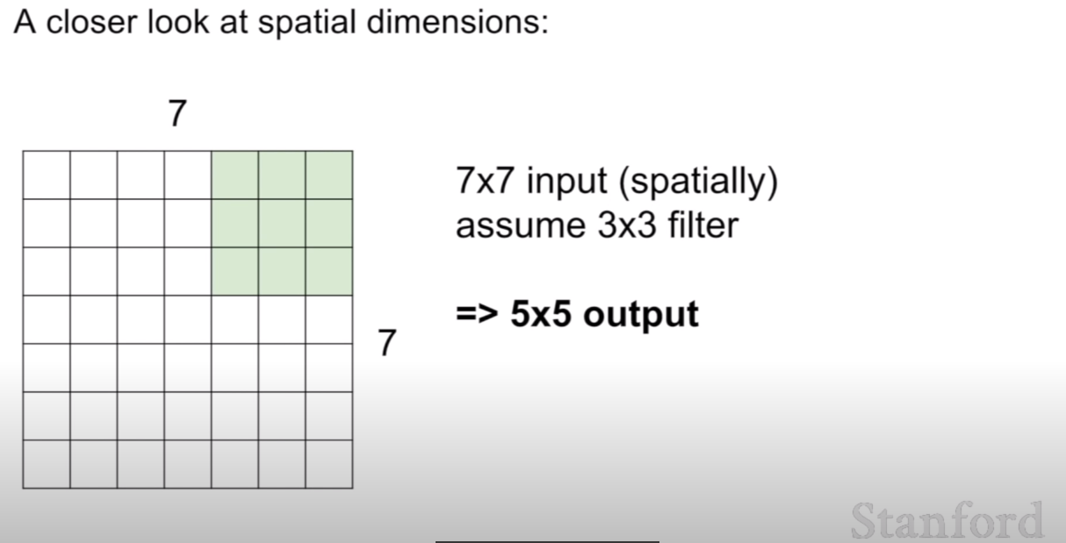

- like below, stride is also a design choice.

- stride is an interval how many cell we pass for each dot-product.

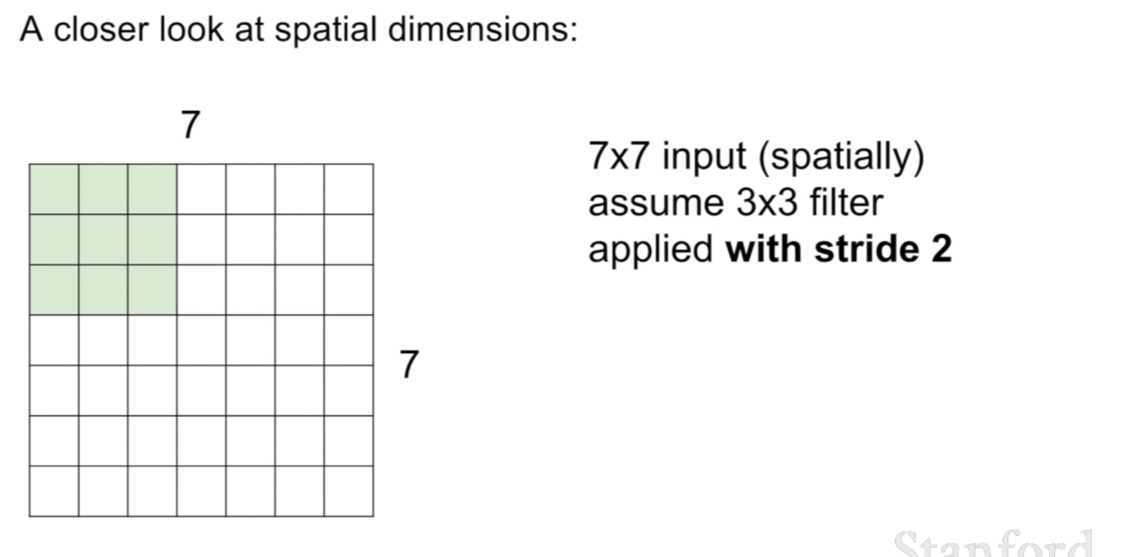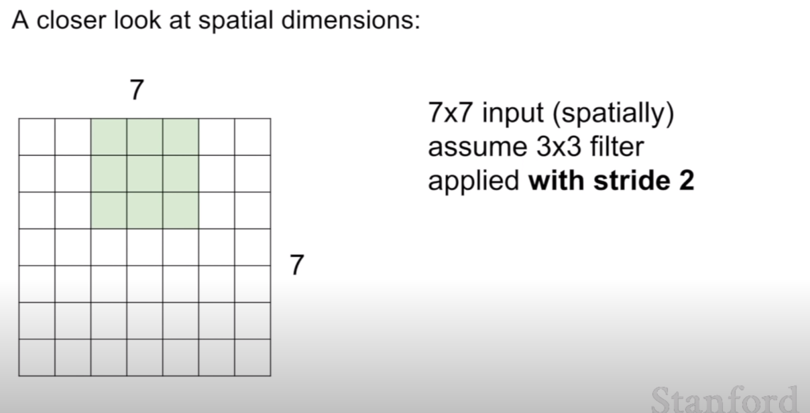

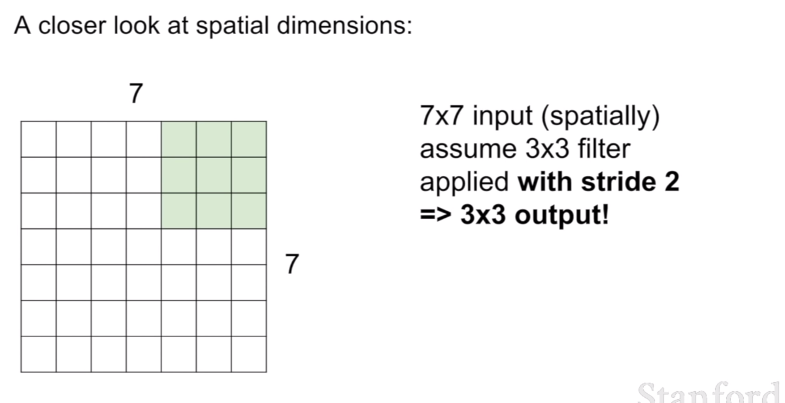

- like above, the greater stride, the small size of output activation map.

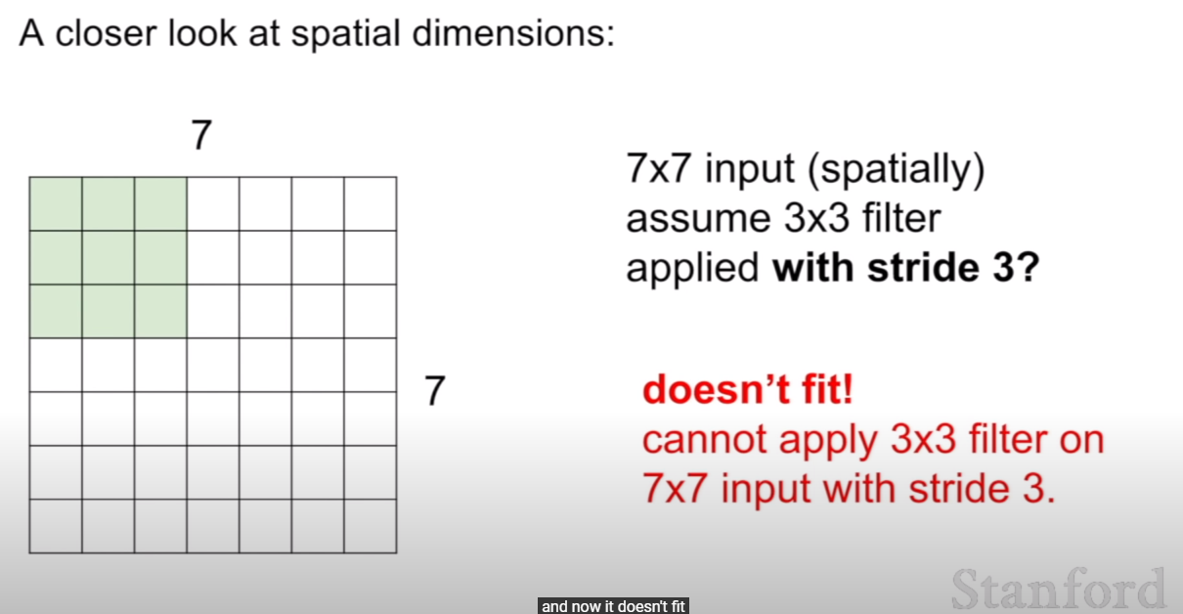

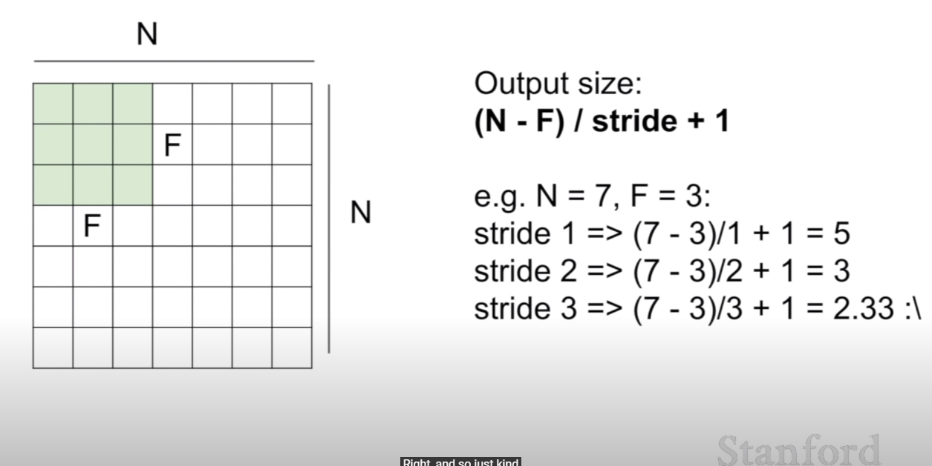

- the formula will return size depending on stride.

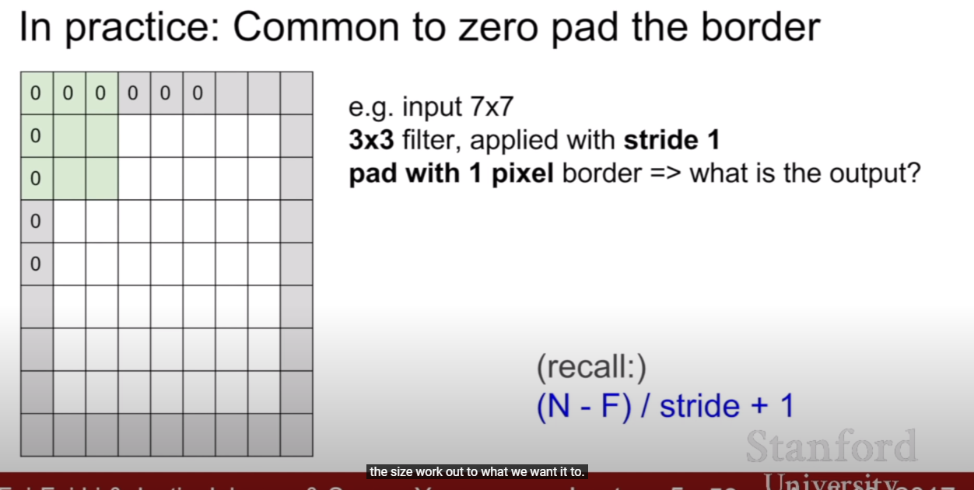

- in practice, we use padding to match the size to our fit. that is, to maintain our input size.

- padding means add 0s to edge of the input volume.

